|  |  |
| --- | --- |
| Student ID | IT23223912 |
| Batch | WD 03.02 |
| **Marking Guide** | |
| App Logo and Launch Screen | **1** |
| User Onboarding Screens | **2** |
| Main Interface Design | **3** |
| Prototype Interaction | **2** |
| Design Aesthetics and Usability | **2** |
| **Total Marks** | **10** |
| Evaluator |  |

**Description:**

**Foodify**

**Foodify** is a user-friendly **recipe-sharing app** designed for food lovers and chefs to explore, create, and share recipes effortlessly. Whether you're a home cook seeking inspiration or a professional chef to showcase your culinary skills, **Foodify** provides a seamless and engaging experience.

**User Onboarding and Authentication**

When launching **Foodify**, users are guided through **three onboarding screens** that introduce the app’s key features. To access the app, users must log in using their **email and password**. **Google and Facebook login options** are also available in the sign in page.

**Main Interfaces and Navigation**

Once logged in, users go to the **Home Page**, which serves as the central hub. A **navigation bar** allows easy access to four additional key sections:

1. **Home Page** – Browse, search, and discover a variety of recipes shared by the community.
2. **Add Recipe** – Chefs can contribute their recipes by filling in details like title, ingredients, direction, time, and images. A dedicated **add icon** on the main interface makes this process quick and simple.
3. **Notifications** – Users receive important updates, including recipe recommendations, alerts, and follower activity.
4. **Profile** – Displays user or chef details, **uploaded recipe count, follower count, and following count**. Chefs can manage their recipes and track their community growth.

**App Logo:**

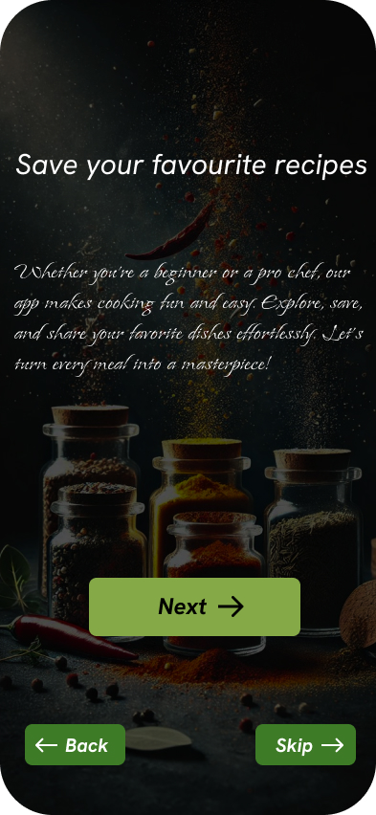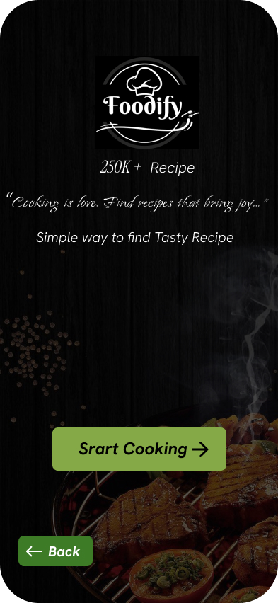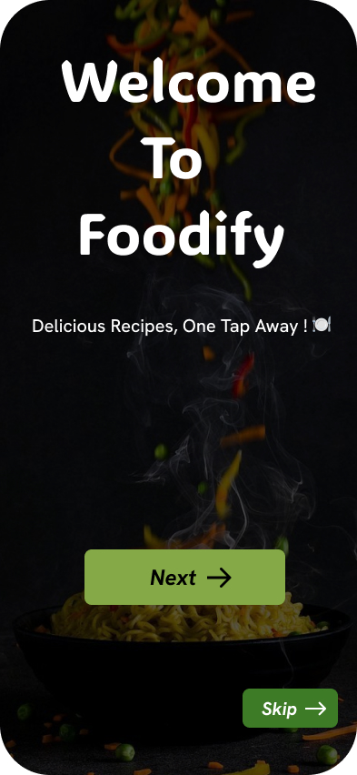**Screenshots:**

Figure – User Onboarding Screens

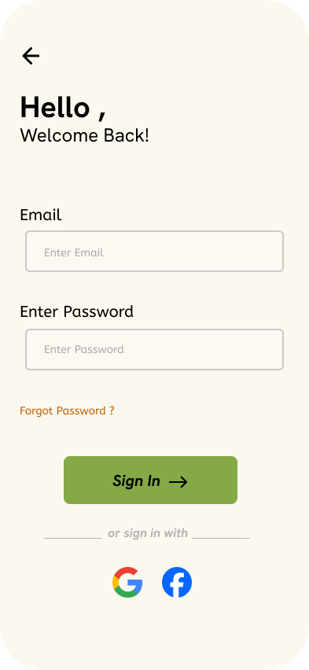

Figure – Home page

Figure – Sign in page

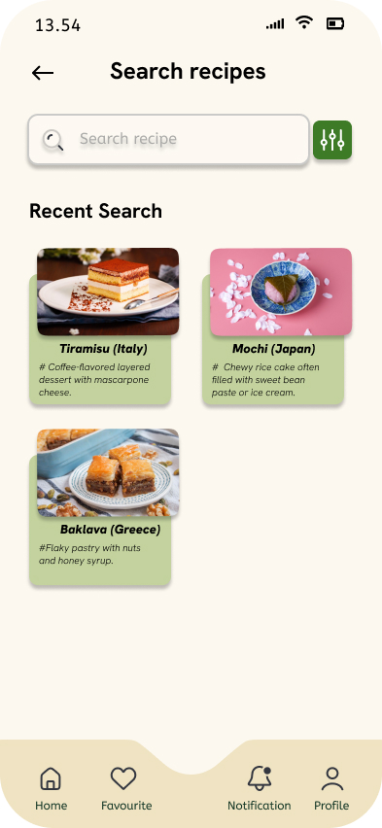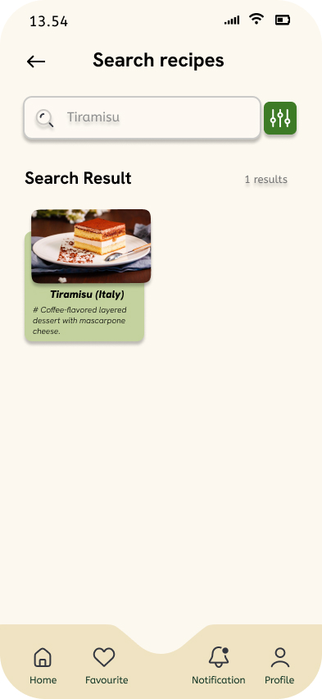

Figure – Search page

Figure – Search result page

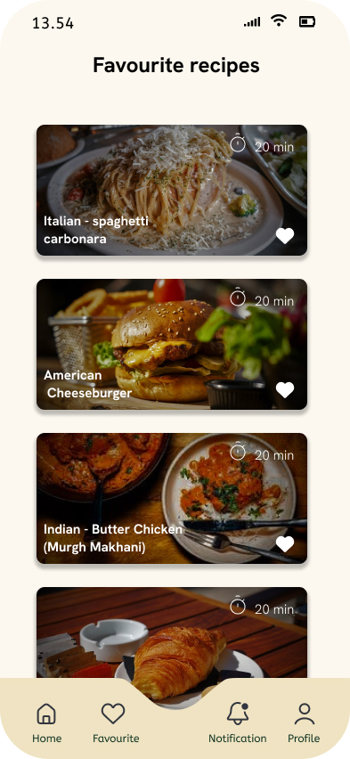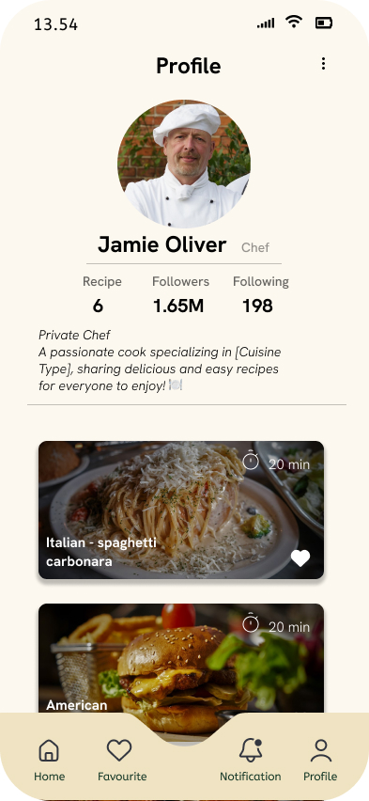

Figure – Favorite recipe page

Figure – Favorite recipe page

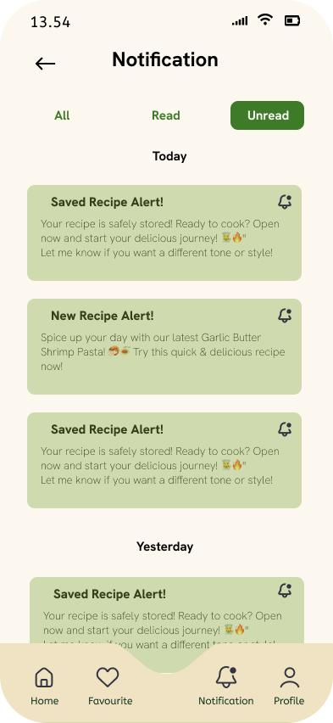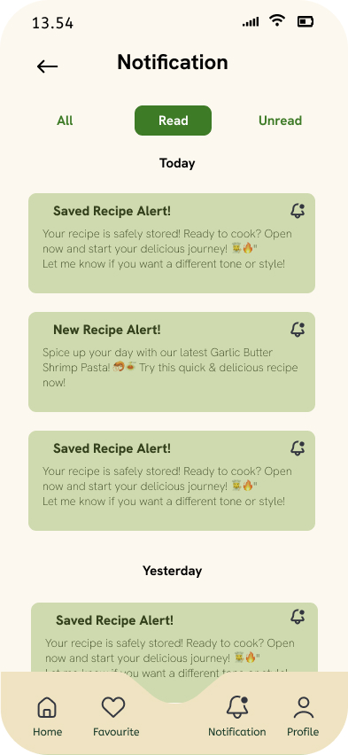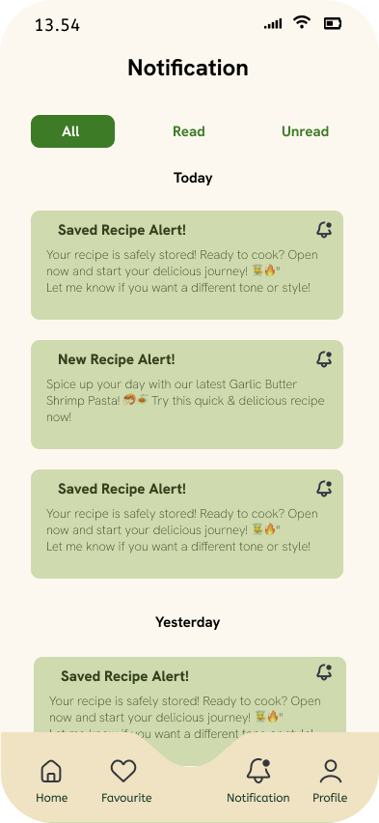

Figure – Notification pages

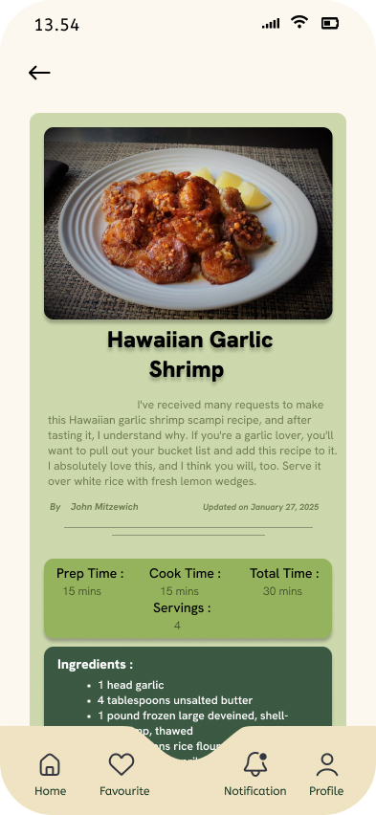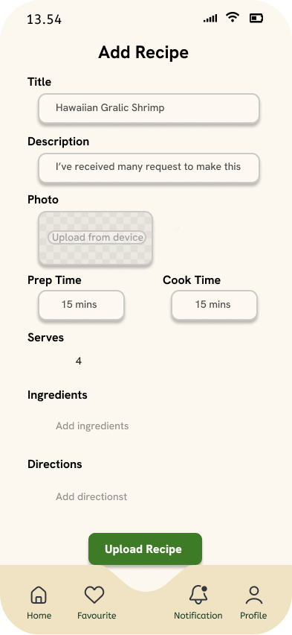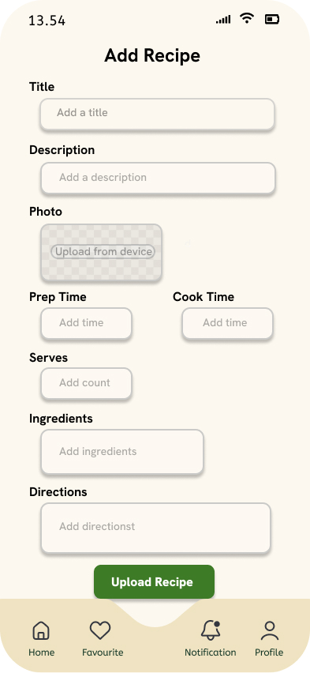

Figure – Recipe page

Figure – Recipe upload pages

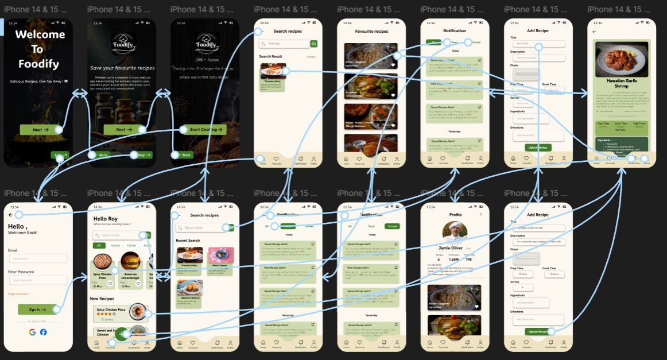**Prototype Interaction:**